|  |  |  |  |  |  |  |
| --- | --- | --- | --- | --- | --- | --- |
| **Document History** | | | | | | |
| **Document Name** | **Version** | **Status** | **Date** | **Viewable** | **Editable** | **Response** |
| Promotion Provider_SDD_0.1 | Promotion Provider_SDD_0.1  **Added**   * Chapter 1 | Introduction * Chapter 2 | System Architecture * Chapter 3 | Detail Design | Draft | 08-07-2015 | TS, NC, PS | TS, NC | NC |
| Promotion Provider_SDD_0.2 | Promotion Provider_SDD_0.2  **Added**   * Chapter 4 | User Interface | Draft | 12-07-2015 | TS, NC, PS | TS, NC | TS |
| Promotion Provider_SDD_0.3 | Promotion Provider_SDD_0.3  **Updated**   * Class Diagram | Draft | 23-07-2015 | TS, NC, PS | TS, NC | TS |

Document Designed by

Tanawat Sitthitan  
Nattakit Chaiwongsri  
July 27, 2015   
  
Document Approved by

_______________   
Mr. Phudinan Singkhamfu

July 29, 2015

Content

Chapter 1 | Introduction 4

1.1 Purpose 4

1.2 Project Scope 4

1.3 Definition, Acronyms, and Abbreviation 4

1.3.1 Key definition 4

1.3.2 Keys Acronyms and Abbreviations 5

1.4 User Characteristic 5

Chapter 2 | System Architecture 6

Chapter 3 | Detailed Design 7

3.1 Class diagram 7

3.1.1 Promotion provider class diagram 7

3.1.2 Promotion provider class diagram description 9

3.2 ER-Diagram 23

3.3 Sequence Diagram 25

3.3.1 URS-01: Admin can login to web server 25

3.3.2 URS-02: Admin can logout from web server 26

3.3.3 URS-03: Admin can add shop owner account 27

3.3.4 URS-04: Admin can edit shop owner account 28

3.3.5 URS-05: Admin can delete shop owner account 29

3.3.6 URS-06: Admin can add promotion to shop owner 30

3.3.7 URS-07: Admin can edit shop owner promotion 31

3.3.8 URS-08: Admin can delete shop owner promotion 32

3.3.9 URS-09: Admin can accept register request 33

3.3.10 URS-10: Admin can reject register request 34

3.3.11 URS-11: Admin can view account list 35

3.3.12 URS-12: Admin can view account information 36

3.3.13 URS-13: Admin can view promotion list 37

3.3.14 URS-14: Admin can view promotion information 38

3.3.15 URS-15: Admin can view user logs 39

3.3.16 URS-16: Admin can view redeem code list 40

3.3.17 URS-17: Admin can view redeem code information 41

3.3.18 URS-18: Admin can view mobile user list 42

3.3.19 URS-19: Admin can view mobile user information 43

3.3.20 URS-20: Admin can search account by shop name 44

3.3.21 URS-21: Admin can search account by email 45

3.3.22 URS-22: Admin can search account by id 46

3.3.23 URS-23: Admin can search promotion by name 47

3.3.24 URS-24: Admin can search promotion by id 48

3.3.25 URS-25: Admin can search promotion by shop name 49

3.3.26 URS-26: Admin can search logs by function 50

3.3.27 URS-27: Admin can search logs by shop name 51

3.3.28 URS-28: Admin can search logs by email 52

Chapter 4 | User Interface Design 52

1. Index page 53

2. Promotion list 54

3. Account list 55

4. Request list 56

5. Add promotion 57

6. Edit promotion 57

7. Add account 58

8. Edit acocount 60

# Chapter 1 | Introduction

## 1.1 Purpose

The Software Design Document (SDD) is document to provide documentation, which will be used to aid in software development by provide the detail of how the software should be built. In the Software Design Document are narrative and graphical documentation of the software design for this project.

This document contains design description of the promotion provider. This includes the architectural feature of the system down though detail of what operations will perform. It also shows how the use cases promised in the SRS would be implementation in the system using this design.

## 1.2 Project Scope

This Software Design Document provides description of the design of the promotion provider. The dominant design methodology is an object-oriented design combines with Model-View-Controller

This Software Design Document is for a high level system, which will work as a proof of the concepts. This software design is focused on the high-level system and critical parts of the system.

## 1.3 Definition, Acronyms, and Abbreviation

### 1.3.1 Key definition

|  |  |
| --- | --- |
| **Design** | “The period of time in the software lift cycle during which the design for architect, software components, interfaces, and data are created, and verified to satisfy requirement.”[IEEE90] |
| **Entity Relationship**  **Diagram** | “data modeling technique that creates a graphical representation of the entities, and the relationships between entities, within an information system.”  [techtarget.com] |
| **iOS** | “the operating system in the iPhone and iPod touch. ” |
| **System Architecture** | “a generic discipline to handle objects (existing or to be created) called "systems", in a way that supports reasoning about the structural properties of these objects.”  [Lix.polytechnique.fr] |
| **Client** | “a client is an application that runs on a personal computer or workstation and relies on a server to perform some operations. For example, an *e-mail client* is an application that enables you to send and receive e-mail.” |

### 1.3.2 Keys Acronyms and Abbreviations

|  |  |
| --- | --- |
| **Key Acronyms** | **Abbreviation** |
| SRS | System Requirement Specification |
| SDD | Software Design Document |
| ERD | Entity Relationship Diagram |
| GUI | Graphic User Interface |
| SD | Sequence Diagram |

## 1.4 User Characteristic

Administrator should be able to:

* Login to web application
* Logout from web application
* Add member account
* Member account
* Delete member account
* Add promotion
* Edit promotion
* Delete promotion
* Accept register request
* Register request

# Chapter 2 | System Architecture

Figure 4.: System Architecture

This project will have 2 sides, the first is client side that is the iPhone application. The client will use apple API to provide a map. The second is server side that is web and database. In this system client need to connect a server, then server will connect to the database and sent the data back to the client via the internet in the form of JSON. The client application cannot retrieve information without connect to server because every data and information of the restaurant of the hotel will store in the database server. User (Hotel or restaurant) can add promotions into our system, and admin can also manage data in the system which are adding, editing and deleting.

# Chapter 3 | Detailed Design

## 3.1 Class diagram

### 3.1.1 Promotion provider class diagram

### 

### 3.1.2 Promotion provider class diagram description

1. Class name: AccountInfo

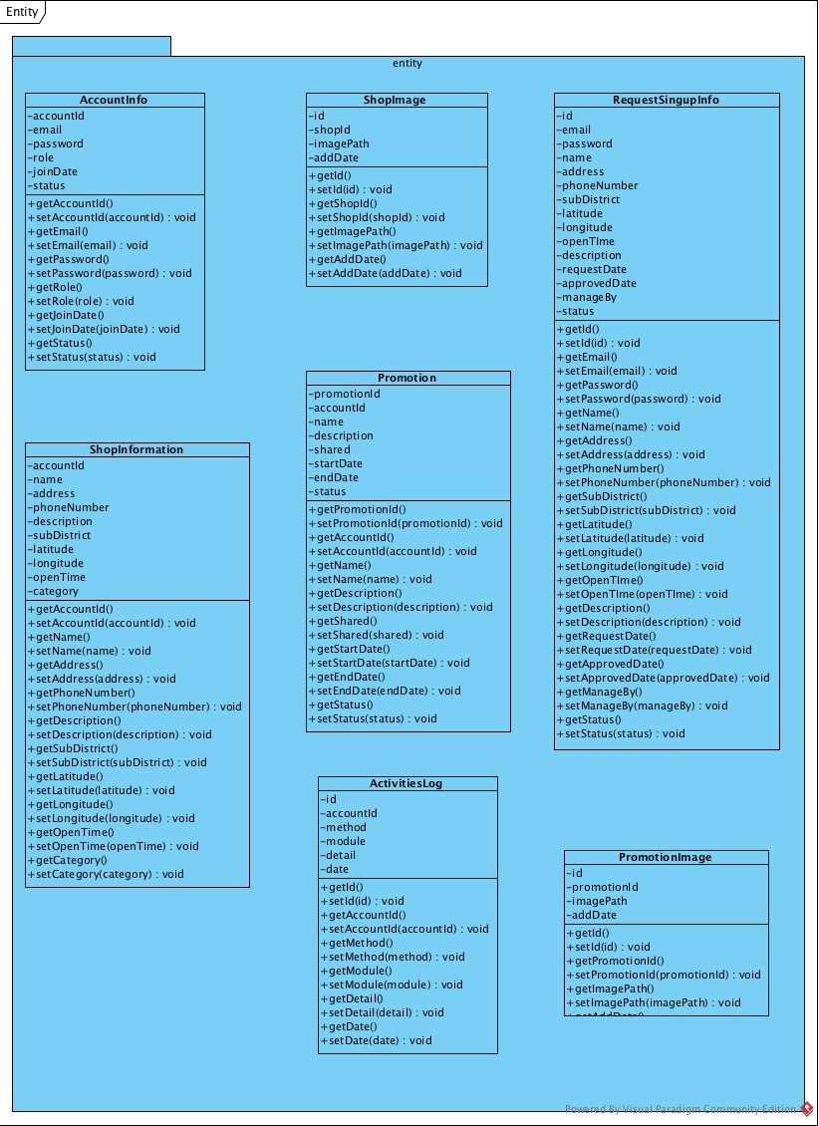

|  |  |  |
| --- | --- | --- |
| **Field Name** | **Description** | **Remark** |
| accountId | Account Id | Type: int |
| email | Email | Type: String |
| password | Password | Type: String |
| role | Role of user | Type: String |
| joinDate | Join Date | Type: Datetime |
| status | Status of user | Type: int |
|  |  |  |
| **Method Name** | **Description** | **Remark** |
| getAccountId() | Method for getting attribute name accountId |  |
| setAccountId(accountId) | Method for setting attribute name accountId | Return Type: void |
| getEmail() | Method for getting attribute name email |  |
| setEmail(email) | Method for setting attribute name email | Return Type: void |
| getPassword() | Method for getting attribute name password |  |
| setPassword(password) | Method for setting attribute name password | Return Type: void |
| getRole() | Method for getting attribute name role |  |
| setRole(role) | Method for setting attribute name role | Return Type: void |
| getJoinDate() | Method for getting attribute name joinDate |  |
| setJoinDate(joinDate) | Method for setting attribute name joinDate | Return Type: void |
| getStatus() | Method for getting attribute name status |  |
| setStuats(status) | Method for setting attribute name status | Return Type: void |

1. Class name: ShopInformation



|  |  |  |
| --- | --- | --- |
| **Field Name** | **Description** | **Remark** |
| accountId | Account Id | Type: int |
| name | Shop Name | Type: String |
| address | Shop address | Type: String |
| phoneNumber | Shop phone number | Type: String |
| description | Shop description | Type: String |
| subDistrict | Shop sub district | Type: String |
| latitude | Latitude | Type: decimal |
| longitude | Longitude | Type: decimal |
| openTime | Shop open time | Type: Datetime |
| category | Shop category | Type: String |
|  |  |  |
| **Method Name** | **Description** | **Remark** |
| getAccountId() | Method for getting attribute name accountId |  |
| setAccountId(accountId) | Method for setting attribute name accountId | Return Type: void |
| getName() | Method for getting attribute name name |  |
| setName(name) | Method for setting attribute name name | Return Type: void |
| getAddress() | Method for getting attribute name adress |  |
| setAddress (address) | Method for setting attribute name address | Return Type: void |
| getPhoneNumber() | Method for getting attribute name phoneNumber |  |
| setPhoneNumber(phoneNumber) | Method for setting attribute name phoneNumber | Return Type: void |
| getDescription() | Method for getting attribute name description |  |
| setDescription(description) | Method for setting attribute name description | Return Type: void |
| getSubDistrict() | Method for getting attribute name subDistrict |  |
| setSubDistrict(subDistrict) | Method for setting attribute name subDistrict | Return Type: void |
| getLatitude() | Method for getting attribute name latitude |  |
| setLatitude(latitude) | Method for setting attribute name latitude | Return Type: void |
| getLongitude() | Method for getting attribute name logitude |  |
| setLongitude(logitude) | Method for setting attribute name logitude | Return Type: void |
| getOpenTime() | Method for getting attribute name openTime |  |
| setOpenTime(openTime) | Method for setting attribute name openTime | Return Type: void |
| getCategory() | Method for getting attribute name category |  |
| setCategory(category) | Method for setting attribute name category | Return Type: void |

1. Class name: ShopImage



|  |  |  |
| --- | --- | --- |
| **Field Name** | **Description** | **Remark** |
| id | Image Id | Type: int |
| shopId | Shop Id | Type: int |
| imagePath | Image Path | Type: String |
| addDate | Add Date | Type: Datetime |
|  |  |  |
| **Method Name** | **Description** | **Remark** |
| getId() | Method for getting attribute name id |  |
| setId(id) | Method for setting attribute name id | Return Type: void |
| getShopId() | Method for getting attribute name shopId |  |
| setShopId(shopId) | Method for setting attribute name shopId | Return Type: void |
| getImagePath() | Method for getting attribute name imagePath |  |
| setImagePath(imagePath) | Method for setting attribute name imagePath | Return Type: void |
| getAddDate() | Method for getting attribute name addDate |  |
| setAddDate(addDate) | Method for setting attribute name addDate | Return Type: void |

1. Class name: Promotion



|  |  |  |
| --- | --- | --- |
| **Field Name** | **Description** | **Remark** |
| promotionId | Promotion Id | Type: int |
| accountId | Account Id | Type: int |
| name | Promotion name | Type: String |
| description | Promotion description | Type: String |
| shared | Amount of shared promotion | Type: int |
| startDate | Date of start promotion | Type: Datetime |
| endDate | Date of end promotion | Type: Datetime |
| status | Status of promotion | Type: int |
|  |  |  |
| **Method Name** | **Description** | **Remark** |
| getPromotionId() | Method for getting attribute name promotionId |  |
| setPromotionId(promotionId) | Method for setting attribute name promotionId | Return Type: void |
| getAccountId() | Method for getting attribute name accountId |  |
| setAccountId(accountId) | Method for setting attribute name accountId | Return Type: void |
| getName() | Method for getting attribute name name |  |
| setName(name) | Method for setting attribute name name | Return Type: void |
| getDescription() | Method for getting attribute name description |  |
| setDescription(description) | Method for setting attribute name description | Return Type: void |
| getShared() | Method for getting attribute name shared |  |
| setShared(shared) | Method for setting attribute name shared | Return Type: void |
| getStartDate() | Method for getting attribute name startDate |  |
| setStartDate(startDate) | Method for setting attribute name startDate | Return Type: void |
| getEndDate() | Method for getting attribute name endDate |  |
| setEndDate(startDate) | Method for setting attribute name endDate | Return Type: void |
| getStatus() | Method for getting attribute name status |  |
| setStatus(status) | Method for setting attribute name satus | Return Type: void |

1. Class name: ActivitiesLog



|  |  |  |
| --- | --- | --- |
| **Field Name** | **Description** | **Remark** |
| id | Activities logs Id | Type: int |
| accountId | Account Id | Type: int |
| method | Method name | Type: String |
| module | Module name | Type: String |
| detail | Activities logs detail | Type: String |
| date | Date | Type: Datetime |
|  |  |  |
| **Method Name** | **Description** | **Remark** |
| getId() | Method for getting attribute name Id |  |
| setId(Id) | Method for setting attribute name Id | Return Type: void |
| getAccountId() | Method for getting attribute name accountId |  |
| setAccountId(accountId) | Method for setting attribute name accountId | Return Type: void |
| getMethod () | Method for getting attribute name method |  |
| setMethod(method) | Method for setting attribute name method | Return Type: void |
| getModule() | Method for getting attribute name module |  |
| setModule(module) | Method for setting attribute name module | Return Type: void |
| getDetail() | Method for getting attribute name detail |  |
| setDetail(detail) | Method for setting attribute name detail | Return Type: void |
| getDate() | Method for getting attribute name date |  |
| setDate(Date) | Method for setting attribute name date | Return Type: void |

1. Class name: RequestSignupInfo



|  |  |  |
| --- | --- | --- |
| **Field Name** | **Description** | **Remark** |
| id | Id | Type: int |
| email | Email | Type: String |
| password | Password | Type: String |
| name | Name | Type: String |
| address | Address | Type: String |
| phoneNumber | Shop phone number | Type: String |
| subDistrict | Shop sub district | Type: String |
| latitude | Latitude | Type: decimal |
| longitude | Longitude | Type: decimal |
| openTime | Shop open time | Type: Datetime |
| description | Shop description | Type: String |
| requestDate | Request sign up date | Type: Datetime |
| approvedDate | Approved sign up date | Type: Datetime |
| manageBy | Who approve or reject sign up request | Type: int |
| status | Status of sign up request | Type: int |
|  |  |  |
| **Method Name** | **Description** | **Remark** |
| getId() | Method for getting attribute name id |  |
| setId(id) | Method for setting attribute name id | Return Type: void |
| getEmail() | Method for getting attribute name email |  |
| setEmail(email) | Method for setting attribute name email | Return Type: void |
| getPassword() | Method for getting attribute name password |  |
| setPassword(password) | Method for setting attribute name password | Return Type: void |
| getName() | Method for getting attribute name name |  |
| setName(name) | Method for setting attribute name name | Return Type: void |
| getAddress() | Method for getting attribute name adress |  |
| setAddress (address) | Method for setting attribute name address | Return Type: void |
| getPhoneNumber() | Method for getting attribute name phoneNumber |  |
| setPhoneNumber(phoneNumber) | Method for setting attribute name phoneNumber | Return Type: void |
| getSubDistrict() | Method for getting attribute name subDistrict |  |
| setSubDistrict(subDistrict) | Method for setting attribute name subDistrict | Return Type: void |
| getLatitude() | Method for getting attribute name latitude |  |
| setLatitude(latitude) | Method for setting attribute name latitude | Return Type: void |
| getLongitude() | Method for getting attribute name logitude |  |
| setLongitude(logitude) | Method for setting attribute name logitude | Return Type: void |
| getOpenTime() | Method for getting attribute name openTime |  |
| setOpenTime(openTime) | Method for setting attribute name openTime | Return Type: void |
| getDescription() | Method for getting attribute name description |  |
| setDescription(description) | Method for setting attribute name description | Return Type: void |
| getRequestDate() | Method for getting attribute name requestDate |  |
| setRequestDate(requestDate) | Method for setting attribute name requestDate | Return Type: void |
| getApprovedDate() | Method for getting attribute name approvedDate |  |
| setApprovedDate(approvedDate) | Method for setting attribute name ApprovedDate | Return Type: void |
| getManageBy() | Method for getting attribute name manageBy |  |
| setManageBy(manageBy) | Method for setting attribute name manageBy | Return Type: void |
| getStatus() | Method for getting attribute name status |  |
| setStatus(status) | Method for setting attribute name status | Return Type: void |

1. Class name: PromotionImage



|  |  |  |
| --- | --- | --- |
| **Field Name** | **Description** | **Remark** |
| id | Promotion image Id | Type: int |
| promotionId | Promotion Id | Type: int |
| imagePath | Image path | Type: String |
| addDate | Add date | Type: String |
|  |  |  |
| **Method Name** | **Description** | **Remark** |
| getId() | Method for getting attribute name id |  |
| setId(Id) | Method for setting attribute name id | Return Type: void |
| getPromotionId() | Method for getting attribute name promotionId |  |
| setPromotionId(promotionId) | Method for setting attribute name promotionId | Return Type: void |
| getImagePath() | Method for getting attribute name imagePath |  |
| setimagePath(imagePath) | Method for setting attribute name imagePath | Return Type: void |
| getAddDate() | Method for getting attribute name addDate |  |
| setAddDate(addDate) | Method for setting attribute name addDate | Return Type: void |

1. Class name: AccountDao

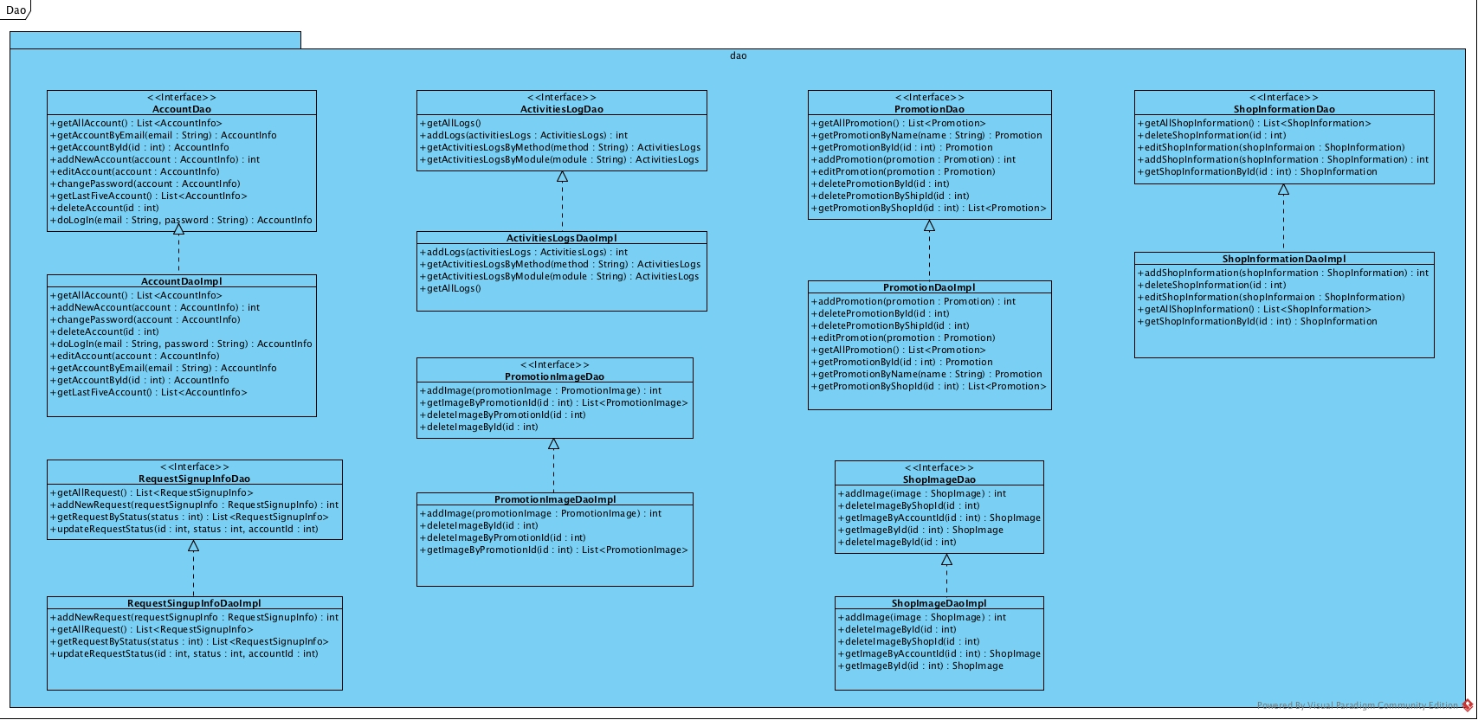

|  |  |  |
| --- | --- | --- |
| **Field Name** | **Description** | **Remark** |
| id | Promotion image Id | Type: int |
| promotionId | Promotion Id | Type: int |
| imagePath | Image path | Type: String |
| addDate | Add date | Type: String |
|  |  |  |
| **Method Name** | **Description** | **Remark** |
| getId() | Method for getting attribute name id |  |
| setId(Id) | Method for setting attribute name id | Return Type: void |
| getPromotionId() | Method for getting attribute name promotionId |  |
| setPromotionId(promotionId) | Method for setting attribute name promotionId | Return Type: void |
| getImagePath() | Method for getting attribute name imagePath |  |
| setimagePath(imagePath) | Method for setting attribute name imagePath | Return Type: void |
| getAddDate() | Method for getting attribute name addDate |  |
| setAddDate(addDate) | Method for setting attribute name addDate | Return Type: void |

Class name: ShopInformation



|  |  |  |
| --- | --- | --- |
| **Method name** | **Description** | **Remark** |
| getId | This method will query Id | Return Id |
| setId(Id) | This method will insert Id |  |
| getAccountId | This method will query accountId | Return accountId |
| setAccountId(AccountId) | This method will insert accountId |  |
| getSubDistrict | This method will query sub district | Return subDistrict |
| setSubDistrict(subDistrict) | This method will insert sub district |  |
| getLatitude | This method will query latitude | Return latitude |
| setILatitude(latitude) | This method will insert latitude |  |
| getLongtitude | This method will query longitude | Return longitude |
| setLongtitude(longtitude) | This method will insert longitude |  |
| getAddress | This method will query address | Return address |
| setAddress(Address) | This method will insert address |  |
| getOpentime | This method will query open time | Return open time |
| setOpentime | This method will insert open time |  |
| getDescription | This method will query description | Return description |
| setDescription | This method will insert description |  |
| getImage | This method will query Image | Return image |

Class name: ShopInformationImpl

|  |  |  |
| --- | --- | --- |
| **Method name** | **Description** | **Remark** |
| getAllShopInformation | This method will query all shop data from the database | Return SQLConnector |
| addNewShopInformation | This method will add new shop to database |  |
| deleteShopInformation | This method will delete a shop from database |  |
| updateShopInformation | This method will updates an existing shop’s information |  |
| getShopInformationById | This method will query shop data from the database by id of shop | Return shop information or null |

Class name: RequestSignup



|  |  |  |
| --- | --- | --- |
| **Method name** | **Description** | **Remark** |
| getId | This method will query Id | Return Id |
| setId(Id) | This method will insert Id |  |
| getEmail | This method will query accountId | Return email |
| setEmail(email) | This method will insert accountId |  |
| getPassword | This method will query sub district | Return password |
| setPassword(password) | This method will insert sub district |  |
| getName | This method will query name | Return name |
| setName(name) | This method will insert name |  |
| getPhoneNumber | This method will query phone number | Return phoneNumber |
| setPhoneNumber | This method will insert phone number |  |
| getSubDistrict | This method will query sub district | Return subDistrict |
| setSubDistrict | This method will insert sub district |  |
| getLatitude | This method will query latitude | Return latitude |
| setLatitude | This method will insert latitude |  |
| getLongitude | This method will query longitude | Return longitude |
| setLongitude | This method will insert longitude |  |
| getAddress | This method will query address | Return Address |
| setAddress | This method will insert address |  |
| getOpentime | This method will query open time | Return open time |
| setOpentime | This method will insert open time |  |
| getDescription | This method will query description | Return description |
| setDescription | This method will insert description |  |
| getImage | This method will query Image | Return image |
| setImage | This method will insert Image |  |
| getRequestDate | This method will query request data | Return requestDate |
| setRequestDate | This method will insert request data |  |
| getApproveDate | This method will query approve data | Return approveDate |
| setApproveDate | This method will insert approve data |  |
| getManageBy | This method will manage by | Return manageBy |

Class name: RequestingSignupDAOImpl



|  |  |  |
| --- | --- | --- |
| **Method name** | **Description** | **Remark** |
| getAllRequest | This method will query all request data from the database | Return SQLConnector |
| getRequestById | This method will query request data from the database by id of request | Return request or null |
| addNewRequest | This method will add new request to database |  |
| deleteRequest | This method will delete a request from database |  |

## 3.2 ER-Diagram

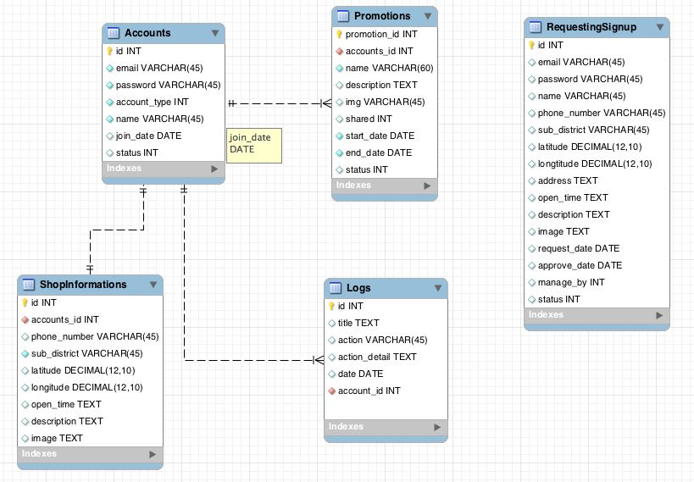

## 3.3 Sequence Diagram

### 3.3.1 URS-01: Admin can login to web server

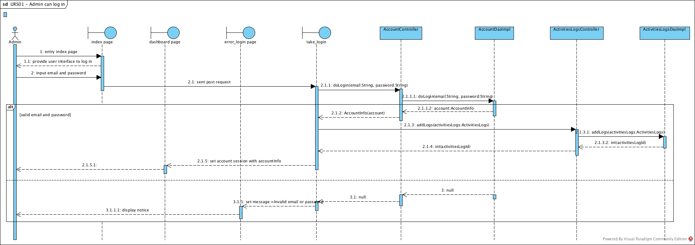

**SD-01** Admin can login to web server sequence diagram

### 3.3.2 URS-02: Admin can logout from web server

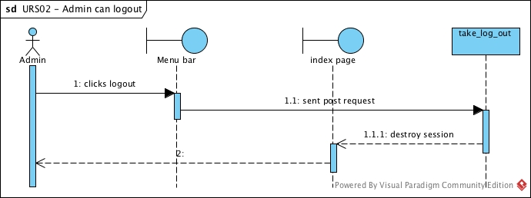

**SD-02** Admin can logout from web server sequence diagram

### 3.3.3 URS-03: Admin can add shop owner account

**SD-03** Admin can add shop owner account sequence diagram

### 3.3.4 URS-04: Admin can edit shop owner account

**SD-04** Admin can edit shop owner account sequence diagram

### 3.3.5 URS-05: Admin can delete shop owner account

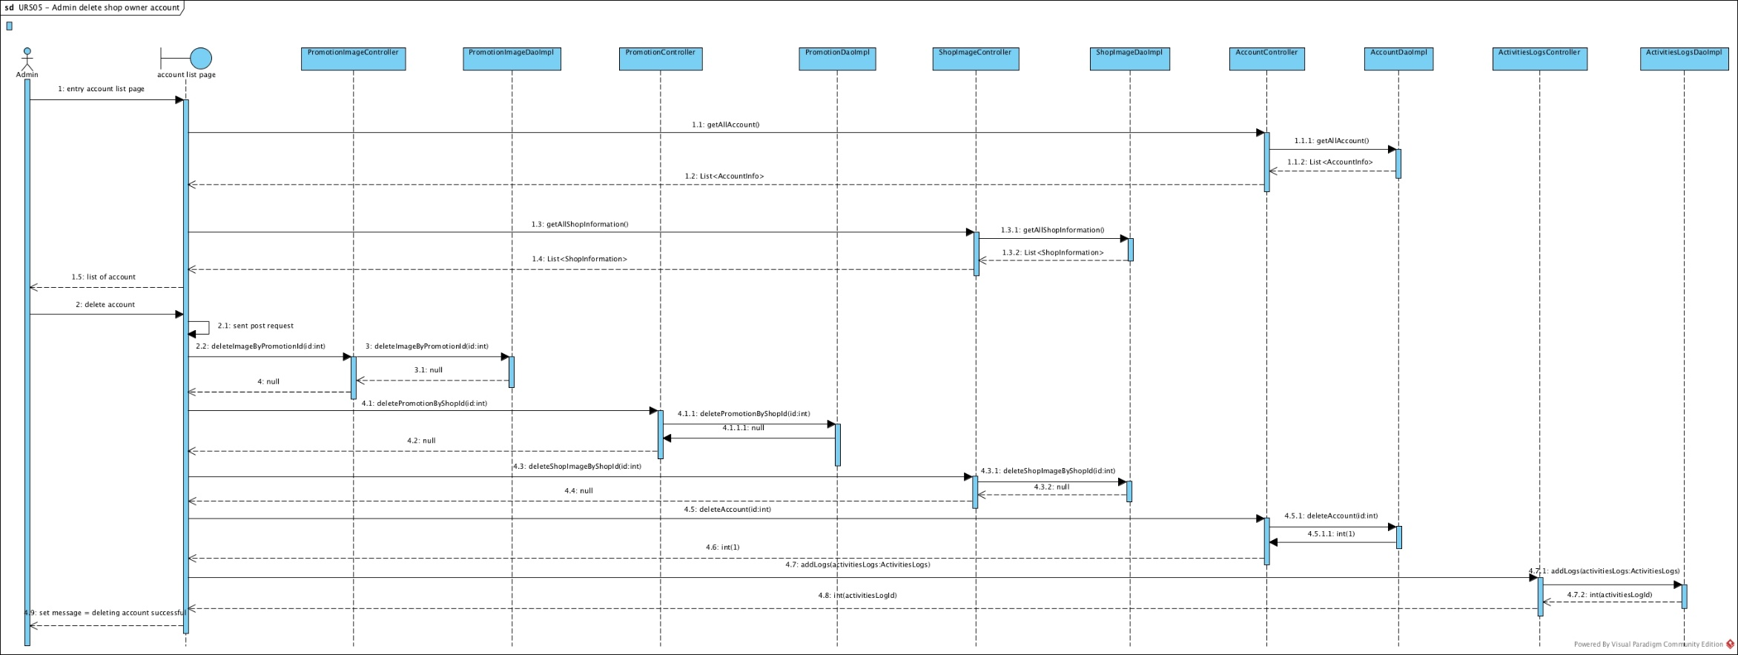

**SD-05** Admin can delete shop owner account sequence diagram

### 3.3.6 URS-06: Admin can add promotion to shop owner

**SD-06** Admin can add promotion to shop owner sequence diagram

### 3.3.7 URS-07: Admin can edit shop owner promotion

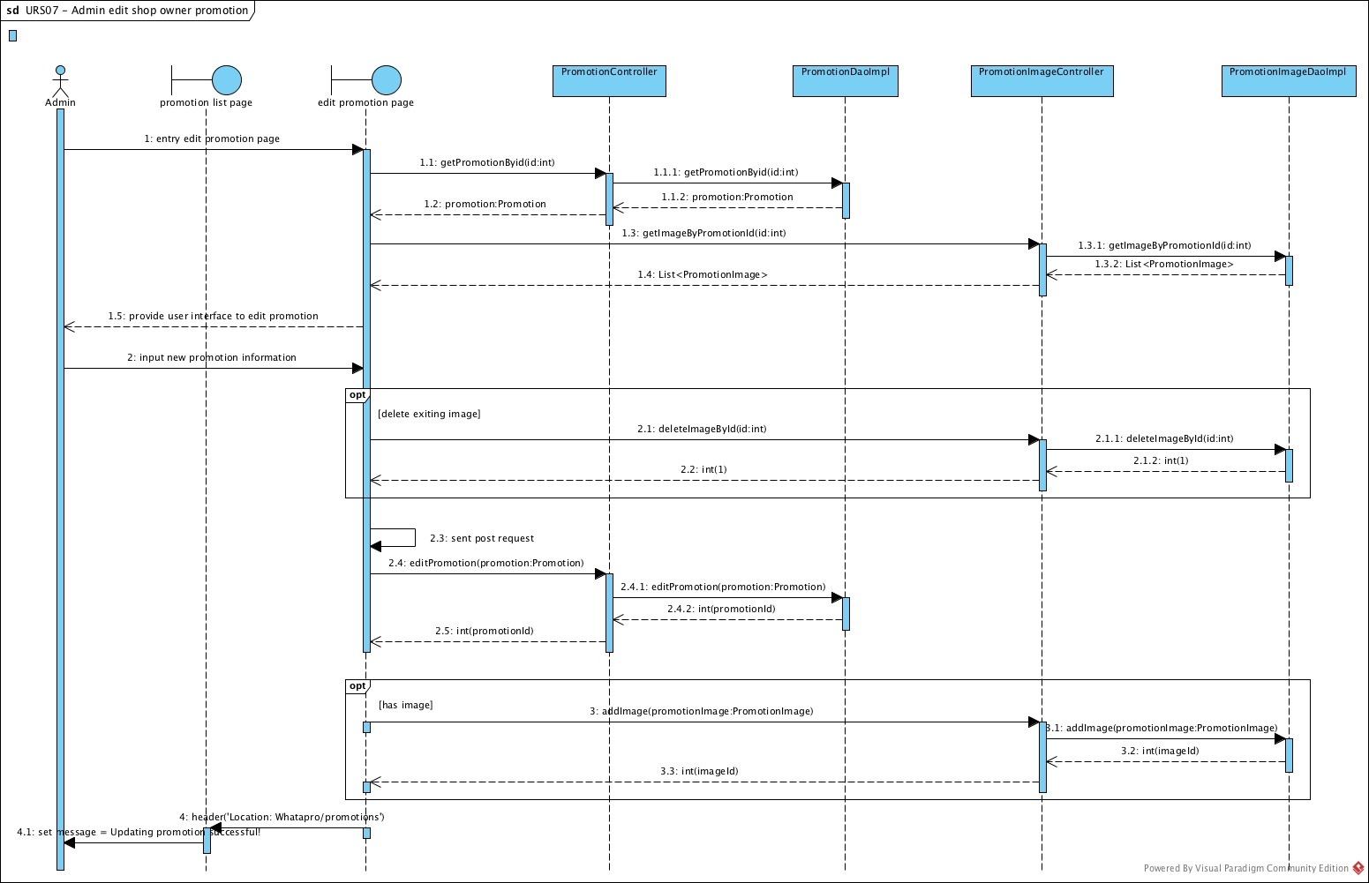

**SD-07** Admin can edit shop owner promotion sequence diagram

### 3.3.8 URS-08: Admin can delete shop owner promotion

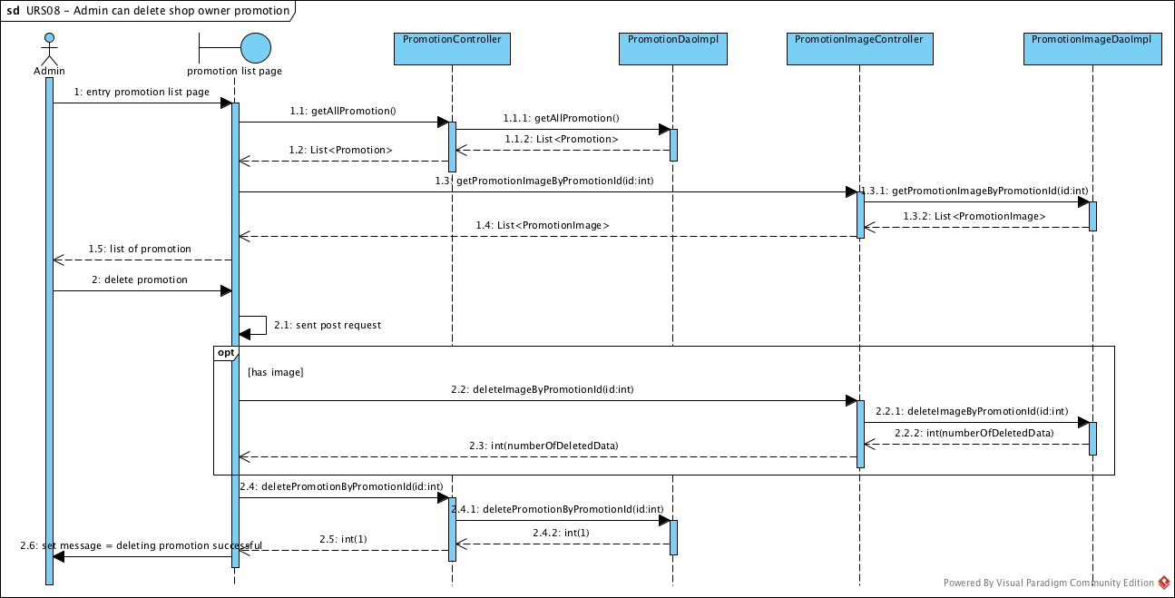

**SD-08** Admin can delete shop owner promotion sequence diagram

### 3.3.9 URS-09: Admin can accept register request

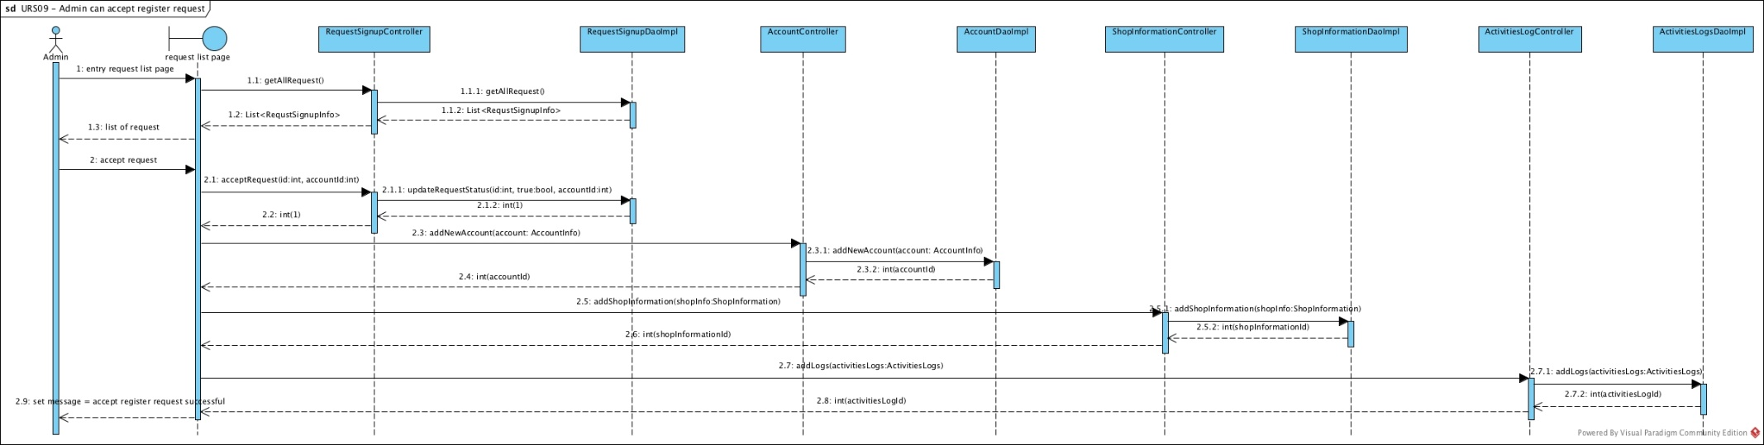

**SD-09** Admin can accept register request sequence diagram

### 3.3.10 URS-10: Admin can reject register request

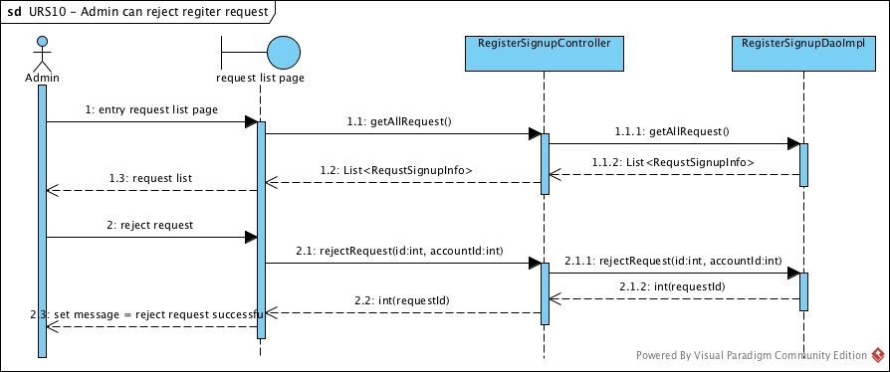

**SD-10** Admin can reject register request sequence diagram

### 3.3.11 URS-11: Admin can view account list

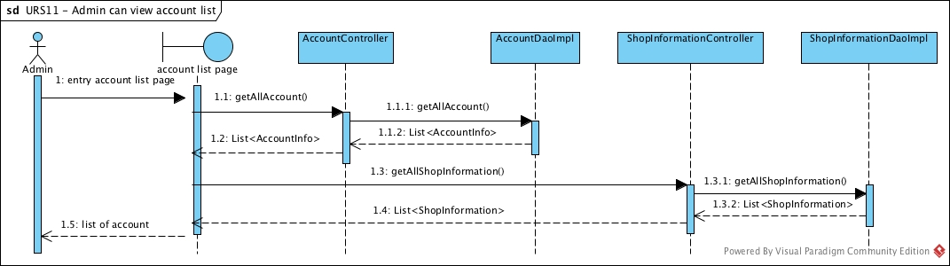

**SD-11** Admin can view account list sequence diagram

### 3.3.12 URS-12: Admin can view account information

**SD-12** Admin can view account information sequence diagram

### 3.3.13 URS-13: Admin can view promotion list

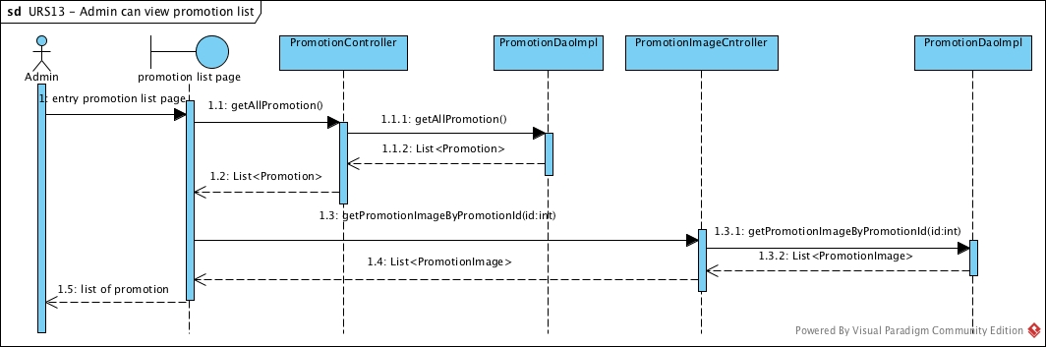

**SD-13** Admin can view promotion list sequence diagram

### 3.3.14 URS-14: Admin can view promotion information

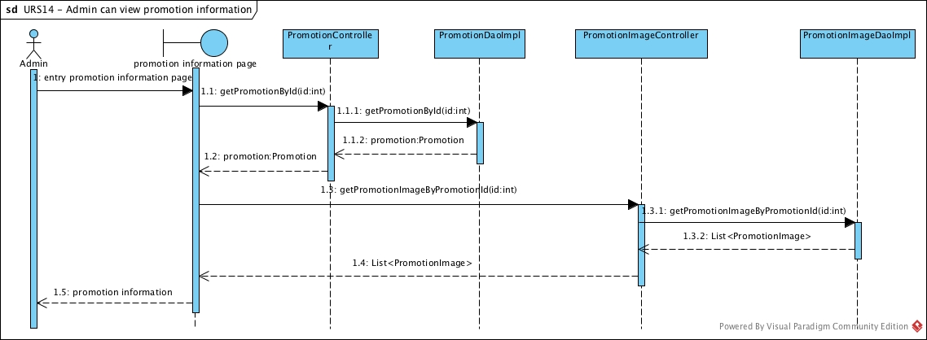

**SD-14** Admin can view promotion information sequence diagram

### 3.3.15 URS-15: Admin can view user logs

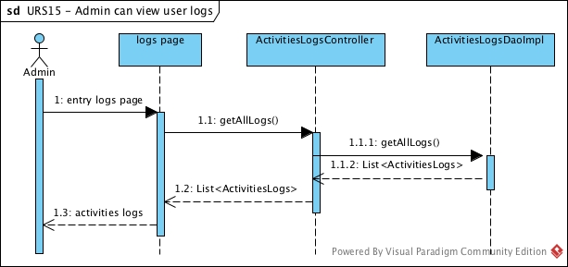

**SD-15** Admin can view user logs sequence diagram

### 3.3.16 URS-16: Admin can view redeem code list

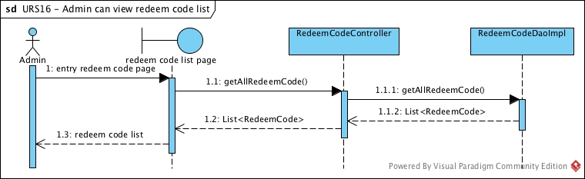

**SD-16** Admin can view redeem code list sequence diagram

### 3.3.17 URS-17: Admin can view redeem code information

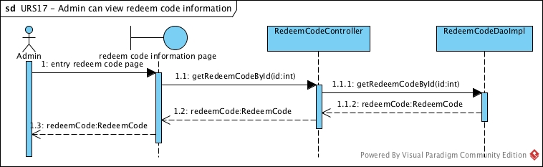

**SD-17** Admin can view redeem code information sequence diagram

### 3.3.18 URS-18: Admin can view mobile user list

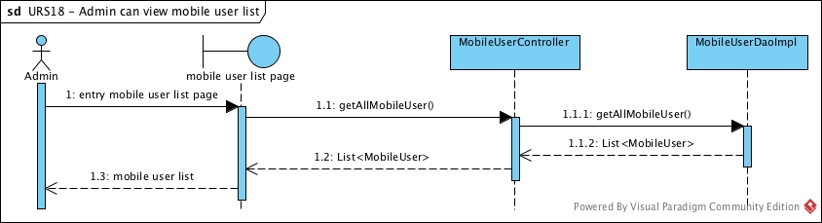

**SD-18** Admin can view mobile user list sequence diagram

### 3.3.19 URS-19: Admin can view mobile user information

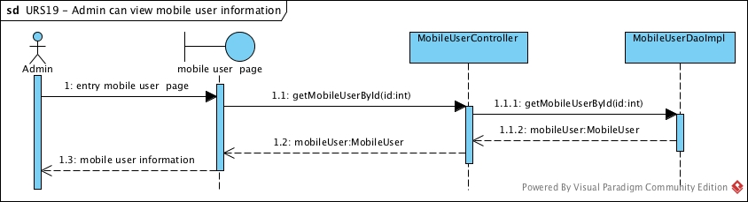

**SD-19** Admin can view mobile user information sequence diagram

### 3.3.20 URS-20: Admin can search account by shop name

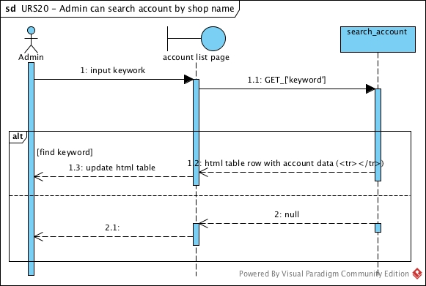

**SD-20** Admin can search account by shop name sequence diagram

### 3.3.21 URS-21: Admin can search account by email

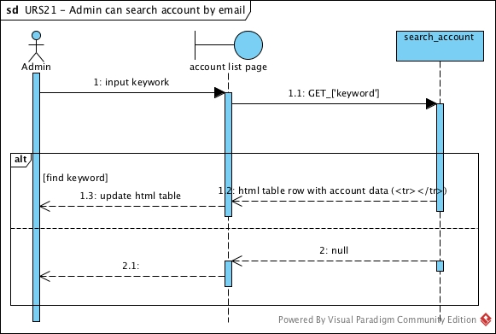

**SD-21** Admin can search account by email sequence diagram

### 3.3.22 URS-22: Admin can search account by id

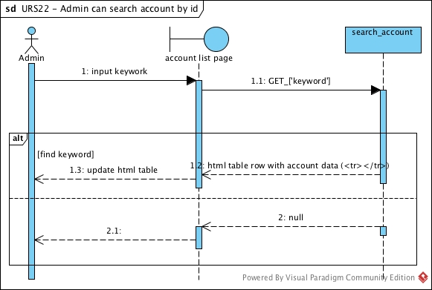

**SD-22** Admin can search account by id sequence diagram

### 3.3.23 URS-23: Admin can search promotion by name

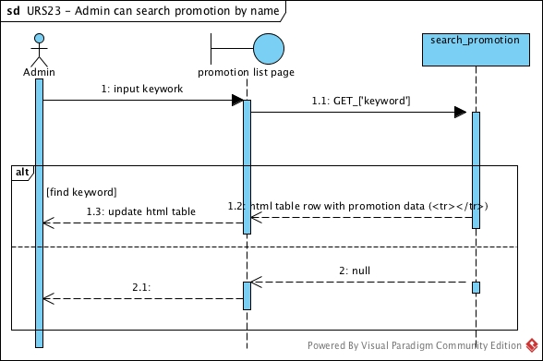

**SD-23** Admin can search promotion by name sequence diagram

### 3.3.24 URS-24: Admin can search promotion by id

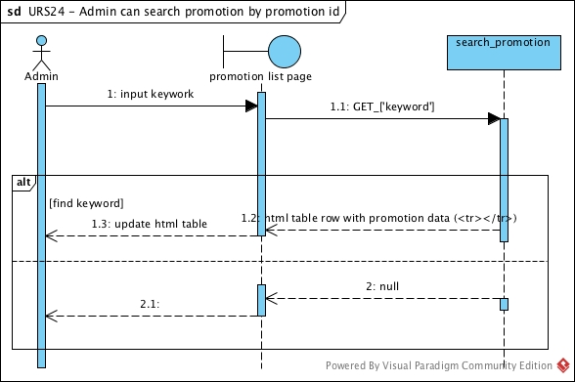

**SD-24** Admin can search promotion by id sequence diagram

### 3.3.25 URS-25: Admin can search promotion by shop name

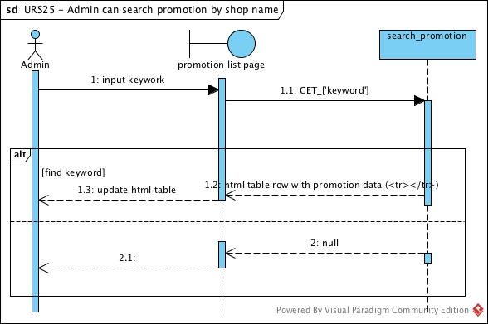

**SD-25** Admin can search promotion by shop name sequence diagram

### 3.3.26 URS-26: Admin can search logs by function

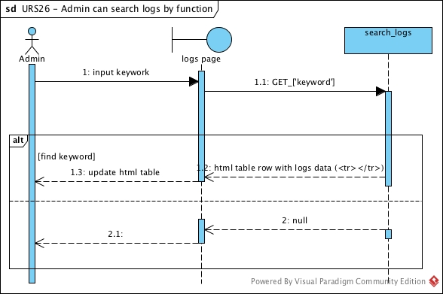

**SD-26** Admin can search logs by function sequence diagram

### 3.3.27 URS-27: Admin can search logs by shop name

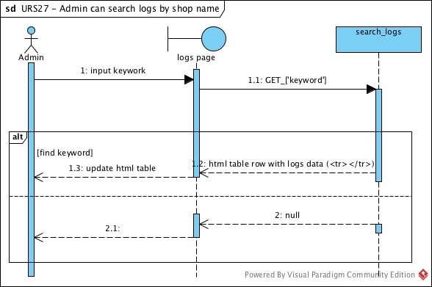

**SD-27** Admin can search logs by shop name sequence diagram

### 3.3.28 URS-28: Admin can search logs by email

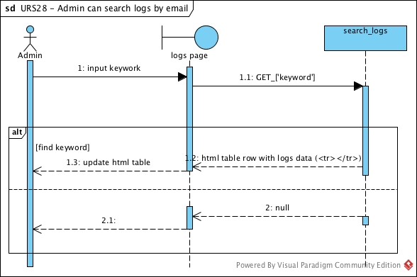

**SD-28** Admin can search logs by email sequence diagram

# Chapter 4 | User Interface Design

## 1. Index page

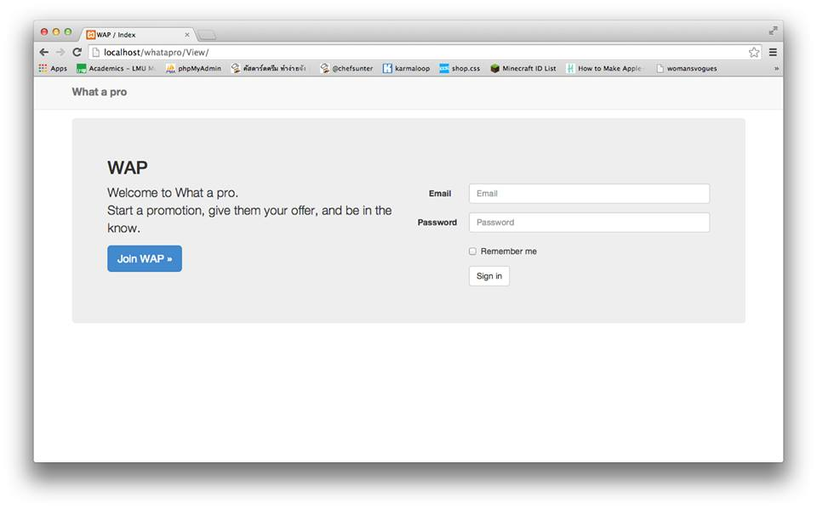This layout presented the main page of web service.

## 2. Promotion list

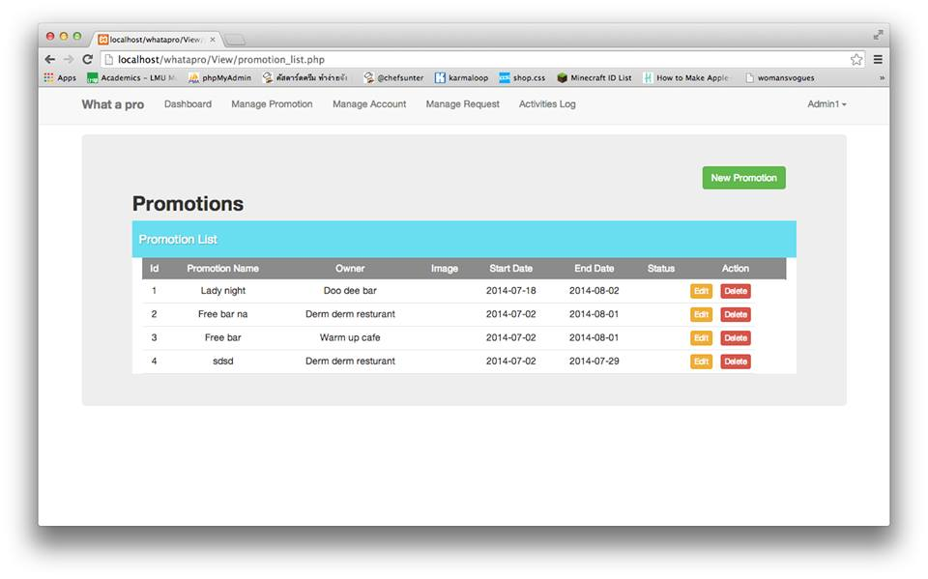

This layout presented the promotion page, allowing to add, edit, delete promotion.

## 3. Account list

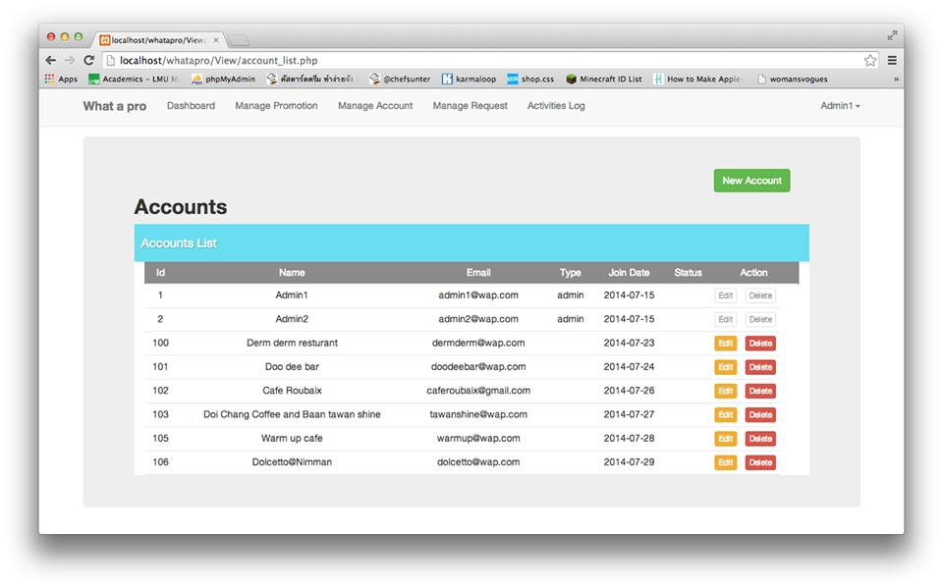

This layout presented the promotion page, allowing to add, edit, delete account.

## 4. Request list

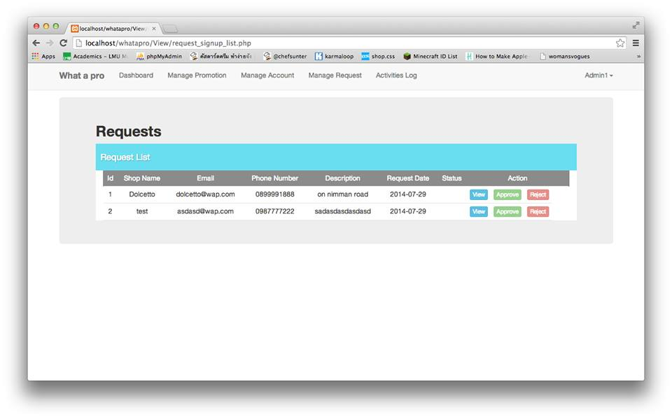

This layout is for admin to see request list and choose to accept or reject from this page.

## 5. Add promotion

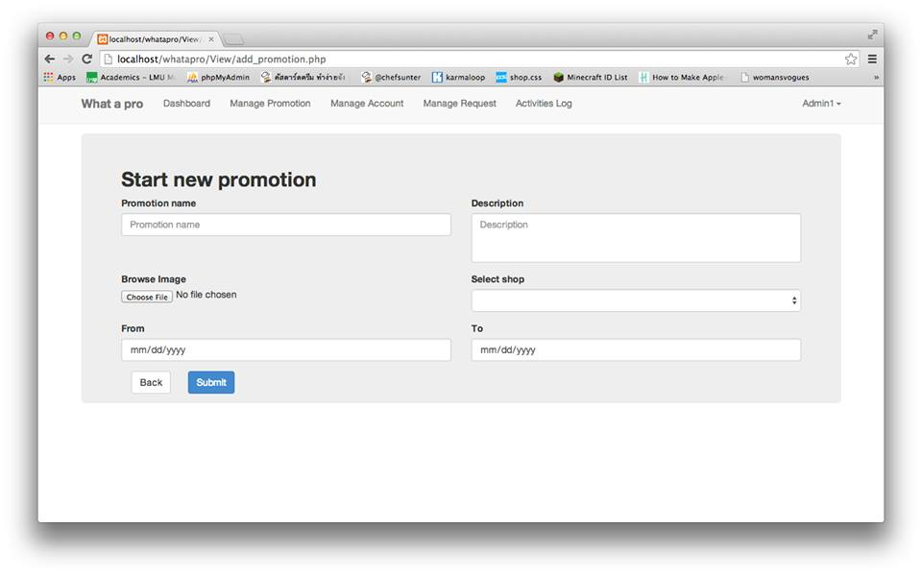

This layout is presenting an application from to add promotion.

## 6. Edit promotion

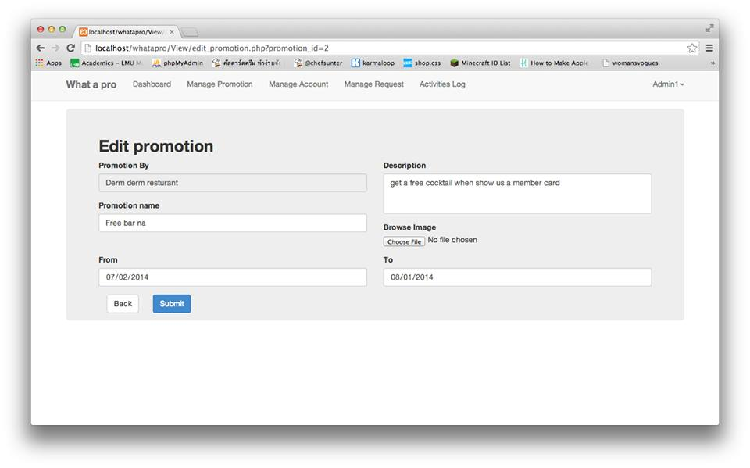

This layout is presenting an application from to add promotion.

## 7. Add account

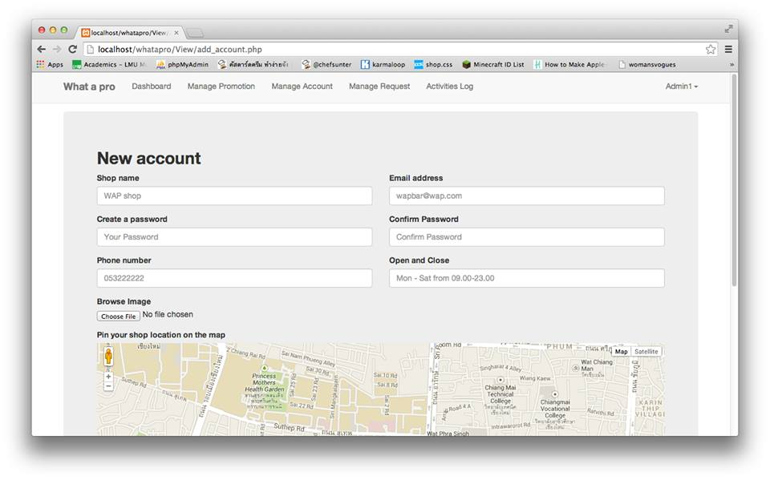

This layout is presenting an application from to add account.

## 8. Edit acocount

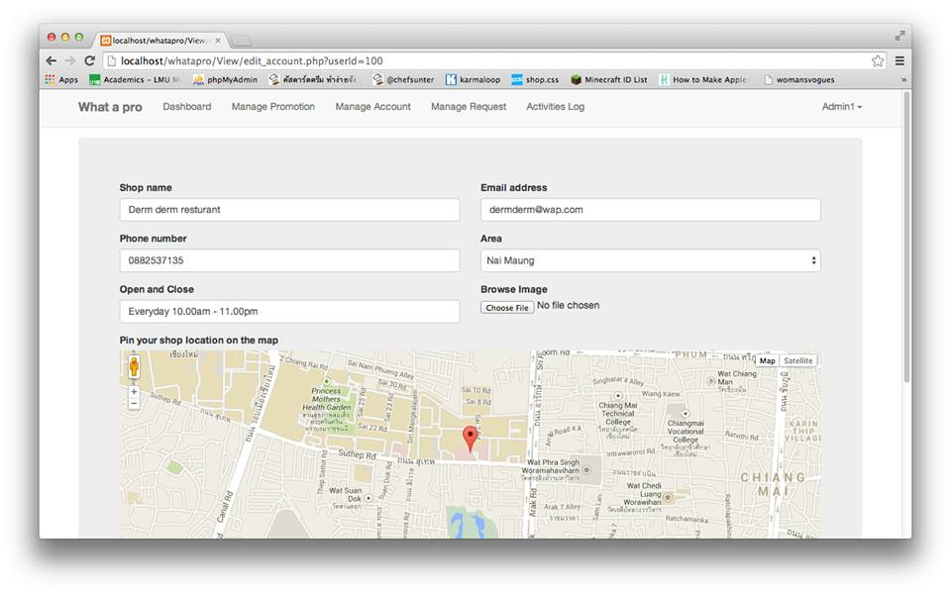

This layout is presenting an application from to edit account.